**Health Care Project Group 7**

Submitted in Partial Fulfilment of requirements for the Award of certificate of

Post Graduate Program in Data Science and Business Analytics

**Capstone Project Report**

Submitted to



Submitted by:

Tanushree Bose

Sushmita Kar

Under the guidance of

Ms. Indumathi Taneja

**PGPDSBA LVC August 2021**

2021-2022

**CERTIFICATE OF COMPLETION SIGNED BY MENTOR**

This is to certify that the participants Tanushree Bose & Sushmita Kar who are the students of Great Learning, have successfully completed their project on Health Care.

This project is the record of authentic work carried out by them during the academic year 2021 - 2022

Mentor

Date:

Place:

<< Email from mentor is also acceptable >>

**ACKNOWLEDGEMENTS**

We would like to express our special thanks of gratitude to Great Learning, who gave us the golden opportunity to do this wonderful project of Model Building and predicting the insurance cost on ‘Health Care’. We came to know about so many new things, we are really thankful for this. It also helped us in doing a lot of research and we came to know about many algorithms and codes.

Secondly, we would like to thank our teacher Mr. Prashant Koparkar for giving us a good understanding on the EDA for our project. And our mentor Ms. Indumathi Taneja for guiding us throughout the project tenure.

Working on this project gave us confidence on working on the real time data, and also made us to push our limits to get better results by using different algorithms.

Date: Tanushree Bose

Sushmita Kar

Contents

LIST OF TABLES 5

LIST OF FIGURES 6

EXECUTIVE SUMMARY 7

**1.** **Problem Statement** 7

**2.** **Data Description** 7

**3.** **Main Results** 8

**4.** **Recommendations** 8

Introduction 10

EDA and Insights 12

Model Development 23

Final Recommendation 26

Appendix 28

# LIST OF TABLES

|  |  |  |
| --- | --- | --- |
| **S.No.** | **Table Name** | **Page No.** |
| 1 | Summary of the Dataset. | 11 |
| 2 | Features Missing Value % Table | 12 |
| 3 | Outlier % Table | 13 |
| 4 | Model Evaluation Table of All Baseline Models | 24 |
| 5 | Model Evaluation Table of GradientBoosting Regressor-Hyperparameter Tuning | 25 |
| 6 | Model Evaluation Table of RandomForest Regressor-Hyperparameter Tuning | 26 |
| 7 | Model Evaluation Table of XGB Regressor-Hyperparameter Tuning | 26 |

# LIST OF FIGURES

|  |  |  |
| --- | --- | --- |
| **S.No.** | **Figure** | **Page No.** |
| 1 | Distplot and Boxplot of Target Variable insurance cost | 13 |
| 2 | Distplot and Boxplot of Variable Daily_avg_steps | 14 |
| 3 | Distplot and Boxplot of Variable BMI | 14 |
| 4 | Distplot and Boxplot of Variable Height | 15 |
| 5 | Distplot and Boxplot of Variable Weight | 15 |
| 6 | Countplot of variable Adventure Sports | 15 |
| 7 | Countplot of Variable Gender | 16 |
| 8 | Countplot of variable Smoking Status | 16 |
| 9 | Countplot of variable Location | 16 |
| 10 | Countplot of Variable Alcohol | 17 |
| 11 | Regplot between daily_avg_steps vs insurance cost | 17 |
| 12 | Regplot between BMI vs insurance cost | 18 |
| 13 | Regplot between weight Vs insurance | 18 |
| 14 | Regplot between Height Vs insurance cost | 19 |
| 15 | Regplot between weight_change_in_last_one_year Vs insurance cost | 19 |
| 16 | Scatterplot between bmi, smoking status and target variable | 19 |
| 17 | Scatterplot between age, smoking status and target variable. | 19 |
| 18 | Scatterplot between weight, smoking status and target variable. | 20 |
| 19 | Barplot between Location, smoking status and target variable. | 20 |
| 20 | arplot between regular checkup last year, Gender and target variable | 21 |
| 21 | Barplot between weight, smoking status and target variable | 21 |
| 22 | Heatmap | 22 |
| 23 | K-mean clustering-Elbow plot | 22 |

# EXECUTIVE SUMMARY

## **Problem Statement**

Everyone’s life revolves around their health. Good health is essential to all aspects of our lives. Health refers to a person’s ability to cope up with the environment on a physical, emotional, mental, and social level. Because of the quick speed of our lives, we are adopting many habits that are harming our health. Few of us spends a lot of money to be healthy by participating in physical activities or having frequent health check-ups to avoid being unfit and get rid of health disorders.

A healthcare insurance company can only make money if it collects more than it spends on the medical care of their customers. On the other hand, even though some conditions are more prevalent for certain segments of the population, medical costs are difficult to predict since most money comes from rare conditions of the patients and certain other factors. The objective of this Project is to accurately predict insurance costs based on people’s data, including age, weight, Body Mass Index, smoking or not, location, etc.

The main purpose of our Project report is to outline the preliminary steps that can be undertaken to build a cost estimation prediction model for an insurance company based on the parameters provided. Additionally, we will also determine what are the most important variable influencing the insurance costs in given data and whether the company needs to focus on other areas too, to strengthen the system of predicting the insurance cost of the customer depending on different factors.

Working on this data will sharpen our capabilities in data science by understanding a raw data. It will allow us to integrate our knowledge and demonstrate our learning, which is also a requirement in Capstone project under the Great learning PG Program in Data Science and Business Analytics with Texas McCombs School of Business, Austin.

The capstone project is a unique opportunity for students to carry out independent group research in order to devise an innovative solution for a real-world problem. This project will allow us to create public data that can be used to show our skills to the potential employers.

The data given to us falls under Supervised Machine Learning category. This is a Regression Analysis problem. Regression analysis is used to predict a continuous target variable

from one or multiple independent variables.

## **Data Description**

For this project, the data has been provided by our ‘Great Learning Team learning repository’. The dataset contains 25000 rows and 24 columns. The columns present in the dataset are given in the data dictionay below:

|  |  |
| --- | --- |
| **Variable** | **Business Definition** |
| applicant_id | Applicant unique ID |
| years_of_insurance_with_u s | Since how many years customer is taking policy from the same company only |
| regular_checkup_lasy_year | Number of times customers has done the regular health check up in last one year |
| adventure_sports | Customer is involved with adventure sports like climbing, diving etc |
| Occupation | Occupation of the customer |
| visited_doctor_last_1_year | Number of times customer has visited doctor in last one year |
| cholesterol_level | Cholesterol level of the customers while applying for insurance |
| daily_avg_steps | Average daily steps walked by customers |
| age | Age of the customer |
| heart_decs_history | Any past heart diseases |
| other_major_decs_history | Any past major diseases apart from heart like any operation |
| Gender | Gender of the customer |
| avg_glucose_level | Average glucose level of the customer while applying the insurance |
| bmi | BMI of the customer while applying the insurance |
| smoking_status | Smoking status of the customer |
| Year_last_admitted | When customer have been admitted in the hospital last time |
| Location | Location of the hospital |
| weight | Weight of the customer |
| covered_by_any_other_co mpany | Customer is covered from any other insurance company |
| Alcohol | Alcohol consumption status of the customer |
| exercise | Regular exercise status of the customer |
| weight_change_in_last_one _year | How much variation has been seen in the weight of the customer in last year |
| fat_percentage | Fat percentage of the customer while applying the insurance |
| insurance_cost | Total Insurance cost |

The insurance_cost column is the target column, and the rest others are independent columns. Independent columns are those with which we will predict the outcome.

## **Main Results**

The best optimum model for the data with difference in score of test and train data of 0.8% and with the highest test score of 95.4% and least RMSE of 2117 among all the other model is **‘Gradient Boosting Regressor’ and ‘XGB Regressor’.**

## **Recommendations**

Based on our dataset we have following recommendation:

* Weight, age, daily_avg_steps, fat percentage, height, bmi, insurance covered by other company are important features that can help the company to build the model for predicting insurance cost for future applicants.
* From our model building and feature importance we have noticed that weight is the most important factor in deciding the insurance cost.
* The customers are fully in control of the premium and the insurance cost. Losing weight decreases the probability of falling sick, which in turn decreases expected medical care costs.
* As the insurance cost depends on weight, so the customers face the full costs of their weight choices through the health insurance premium. And in turn the company will face less complains and can sustain its clients for longer.
* As weight is the most important feature, so customers are being rewarded indirectly for good lifestyle and by controlling their weight and hence creates positivity because they are explicitly rewarded for the benefits they generate by claiming minimal towards the policy.
* Overweight means high premium and weight of the customer can give the company a lot of information about the customer’s health. Because obesity can cause various health problems like cholesterol, heart disease, blood sugar and other diseases too. With the help of weight company can actually make a good profiling of the customer’s health prediction and hence control the insurance cost accordingly. And hence weight variable can help us to understand these variables in our dataset too.
* If the weight increases the BMI also exceeds, and in this case, customer may consider exercising to reduce the weight to reduce the insurance cost because otherwise the customer will have to pay higher premium. Hence, we can see that the BMI and exercise variable can also be studied with the help of the weight variable.

**Other Recommendation:**

* Gender is a very important factor and not much influencing the insurance cost. Considering Gender and Age the insurance cost of the individual applicant should be decided.
* While looking into the data we noticed that most of the customers don’t have any pre-existing disease, heart

disease or any other disease. This information of data is not very helpful for the company. We would like to

recommend the company to looking into the past medical records of the applicant as they are crucial in

deciding the cost. If the applicant has a history of suffering from illnesses or have a pre-existing disease, then

their premium will be higher.

* During our analysis we noticed that location is not playing any crucial role in deciding the insurance cost. As

Location plays an important role in deciding the insurance cost. Company should have higher insurance cost

for different locations. For certain geographic locations, the premium rates should be high due to lack of

healthy food options, climate and health issues. Also, if the live in a place where medical costs are higher

than average, the premium will likely be higher, and if the customer live in a place where costs are lower than average, the premium will be lower. And usually, metropolitan cities have higher medical cost than that of

the towns.

* Only 15% of the applicant are **smokers** in this dataset. Which will not lead to any profitability of the company. As we are aware smoking increases health risk. We recommend the company to investigate the data to revalidate the record as 85% of the data shows the applicant are not smoking.
* This dataset shows only 10% of the applicant are consuming **alcohol** which is a very small segment of the applicants. Like smoking habits, alcohol consumption also increases health risk.

Hence, company should focus on this kind of applicant more for the profitability of the company.

* Age, one of the critical factors which affect the insurance cost. Our current dataset shows no evidence of high or low insurance cost against the age of the applicant. Generally, the insurance company should follow one thumb rule- higher the age, higher the cost. Older people are more at a higher risk of suffering from illness than youngsters.
* In our data base occupation is not influencing the insurance cost of the customer. Applicant’s nature of work

and the amount of risk that they are exposed to at work, affects the premium charges. Someone who is a

student, their premium will be less, but if someone works in an environment like a construction site or a

factory where the risk of being injured is high, then the premium amount will be higher.

Company should focus more on applicant who are salaried and business personal. Long hour of work,

unhealthy lifestyle, stress leads to health risk.

* BMI**-**which is another factor which affects the insurance cost shows no relevant information in our dataset. i.e. applicant with high BMI should pay high insurance cost. People with high BMI are at risk of serious ailments including heart diseases, type 2 diabetes, breathing problems, high blood pressure and cancer. Company should review their record as the dataset doesn’t show high insurance cost for applicant who are having high BMI’s.
* Our dataset does not have record of applicant **dependents** like how many children they have. Insurance cost can be more for a plan that also covers a spouse and/or dependents. So, a company can introduce a new column which gives information about family.
* Another factor which we felt company can take into consideration is the applicant who are **enrolling new**. Years of insurance with the company can play a vital role too, new applicants would make frequent trips to doctors and hospitals to start reaping benefits of the health insurance policy. Therefore, they increase the premium rates to cover all expenses. Hence, company can charge more insurance cost to these kinds of applicants.
* Company should target more customers who are into adventure sports, as they need a good insurance policy due to the injury risk.

# Introduction

We all know that Health care is very important domain in the market. It is directly linked with the life

of an individual, hence we have to always be proactive in this particular domain. From the prospective of healthcare insurance industry, data science predictive model application is the most versatile application to solve their industry business problem.

Money plays a major role in this domain, because sometime treatment becomes super costly and if any individual is not covered under the insurance, then it will become a pretty tough financial situation for that individual. The companies in the medical insurance also want to reduce their risk by optimizing the insurance cost.

Data Science is enabling the Healthcare insurance company to deliver better services while lowering the costs. While the help of data science the insurance industry market is constantly developing. As a result, areas such as cost savings, quality of service, fraud detection and prevention, and increased consumer involvement may all improve dramatically.

The Objective to use Data Science application in the Healthcare Industry is to **speed up the interaction with customers, give more tailored products and services, automate simple communication, improve customer satisfaction, and configure the most beneficial offer in no time**.

It will also help in building a comprehensive view of patients, consumers, and clinicians. Data-driven decision-making opens up new possibilities to boost healthcare quality.

We have secondary source of Data i.e. Healthcare Data which have been provided by Great Learning Team. The **Goal & Objective of** this exercise is to build various Machine Learning models, to predict the optimum **insurance cost** for an individual.

Insurance cost is based on different variables. as a result, insurance cost are continuous values. Therefore, regression algorithms are the best choice available to fulfill our needs. We will use multiple regression algorithms in this analysis since there are many independent variables that will be used to calculate the dependent(target) variable.

We will be preprocessing the dataset first, then we train all regression models with training data and finally evaluated those models based on testing data. In this project, we used supervised ML models to demonstrate and compare the accuracy of various regression models, for example, rf, decision tree, Boosting model like Gradient, xgb and adaptive, Bagging and neural network.

We found that the Gradient boosting and Random Forest ML algorithms are providing the highest accuracy with an r-squared value of 95%. The key reason for this study is to include a new way of estimating insurance costs.

To summarize the main contributions of this Project:

(i)Investigating the applicability of the machine learning-based computational intelligence approach for predicting healthcare insurance cost in the healthcare industry section.

(ii)Comparing the performance results of the most popular machine learning algorithms for forecasting the costs of healthcare insurance by using a public dataset.

(iii)Providing a guide for developers to choose the appropriate machine learning method when developing an effective healthcare insurance cost prediction system.

**Information about the Dataset**:

1. The dimension of the data: Rows: 25000, Columns: 23.
2. There are 8 categorical and 15 numerical columns here. Specifically, there are 2 Float Type, 14 integer type & 8 object type.
3. There are missing values in columns ‘bmi’ and ‘Year_last_admitted’.

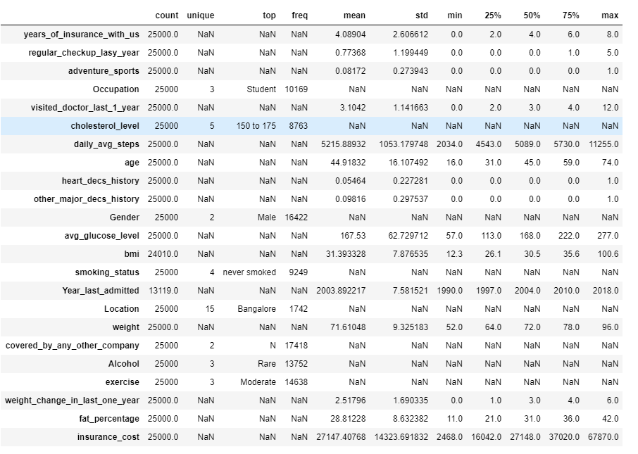

Table 1: Summary of the Dataset.

**Observation:**

1. ***The independent variables are***: years_of_insurance_with_us, regular_checkup_lasy_year, adventure_sports, Occupation, visited_doctor_last_1_year, cholesterol_level, daily_avg_steps, age, heart_decs_history, other_major_decs_history, Gender, avg_glucose_level, bmi, smoking_status, Year_last_admitted, Location, weight, covered_by_any_other_company, Alcohol, exercise, weight_change_in_last_one_year, fat_percentage.
2. ***Dependent/Target Variable*** *is*: insurance_cost, the average insurance cost of patient is 27147.40768, with minimum being 2468.0 and maximum of 67870.0.
3. There are missing values in 'bmi' and 'year_last_admitted' column.
4. There are outliers in few columns like bmi, daily_avg_steps, other_major_diseases_history, are showing maximum value quite high, suggesting presence of outliers. Need to look into these columns.
5. From the above statistics we can infer that the average age of the applicant is approx. 45 years.
6. The average weight of the applicant is approx. 72 kg with bmi rate of approx. 31.
7. We can also infer from above output that median age of applicant is 45 years, with approx. median weight of 72 and bmi of 30.5.
8. Most of the applicant are student, applicant are taking insurance from same company for consecutive 3 years.
9. Most of the applicants are male and the data shows that most of the applicant never smoked, consumed alcohol rare and exercised moderately.

***Rename Column****:* There are some spelling mistakes in the data, we will fix those first. We will change the name of the variable ‘regular_checkup_lasy_year’ to ‘regular_checkup_last_year’ and in ‘Occupation”

variable the spelling of one of the categories named ‘Salried’ to ‘Salaried’.

***Duplicate Values***: There are no duplicate values.

***Missing values****:*

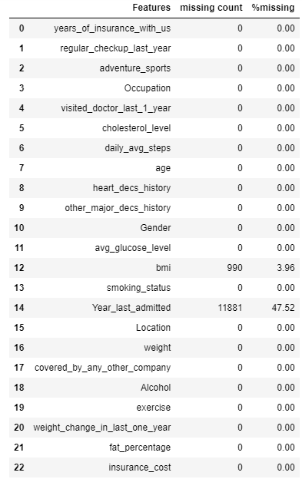

Table 2: Features Missing Value % Table

**‘bmi’** has 990 missing values which is 3.95%. After further analysis we will see how to impute the null

values in this variable after studying other variable which may affect its values.

**Year_last_admitted**: This column shows approx. 48% of missing value in the dataset. This is a year column. We would not be using a Year as a feature because when we use our predictive model in the future then those future years won’t be included in the dataset. Also, because all other year information has not been captured in the dataset, so it is an ideal approach to drop the column for our further data analysis.

# EDA and Insights

**Data Pre-processing**

**Null value imputation of bmi.**

**BMI:**

* We will make a separate column name with height, and we will fill its values with the help of bmi and weight.
* once we get the height then we will fill the null values of height with the median value by group by the 'Gender as the average height of male and female is different.
* once we fill the height null values, then from the height and weight we will impute 'bmi' missing values.

**Outlier Treatment:**

We did outlier treatment for BMI, height and daily_avg_steps feature.

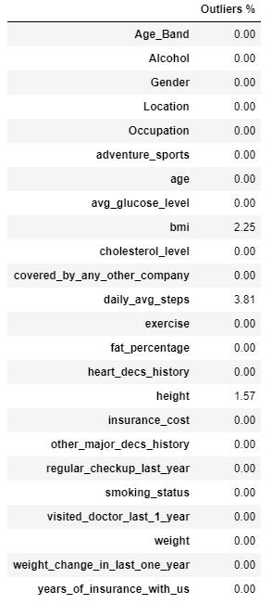

Table 3: Outlier % Table

**Converting Categorical variables to object type.**

We will convert categorical variables to object type. Variable like adventure sports, heart disease history

and other heart disease history are numerical in the dataset. For proper Visualization, we will convert the

‘1 and 0’ values into ‘Y and N’ so that we can do the analysis with other categorical variables.

### **We will perform some feature engineering to understand the data better.**

* We will assign age band to age column so that we can understand the age distribution better, in relationship with the insurance cost.
* For cholesterol_level value ranges are given so we will assign sub-categories for each range so that we can analysis it better.
* In the numerical columns there are many discreet columns we will assign dtypes of these columns and convert them to categorical which will help us to analysis them better.

Once we are done with these feature engineering of the columns then we will go ahead and start doing our Uni, bi and multi variate analysis.

**Uni-Variate Analysis:**

**Insurance Cost (Target Variable):**

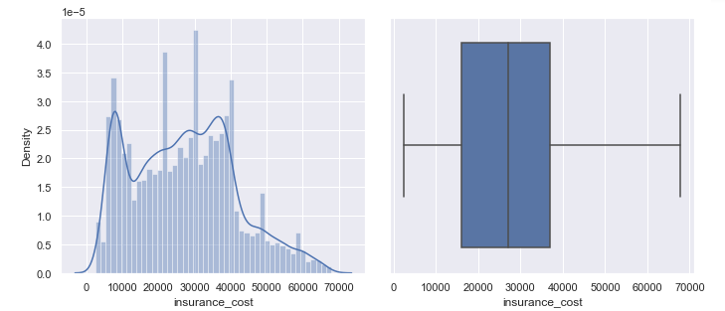

Figure 1: Distplot and Boxplot of Target Variable insurance cost

* The above plot shows that our target variable is little right skewed.
* Majority of the customers are having insurance cost between 15k to 38k.
* Doesn’t show any outliers.
* Insurance cost of applicant starts from min amount of 2468 to max of 67870.

**Daily_avg_steps**:

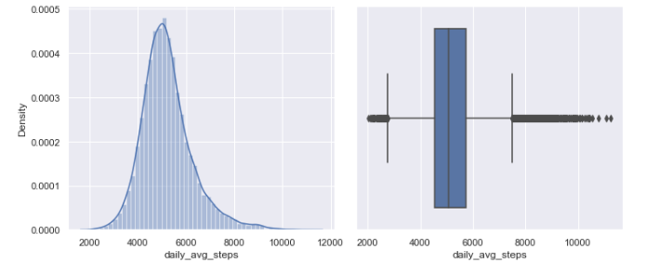

Figure 2: Distplot and Boxplot of Variable Daily_avg_steps

* Most of the steps falls in the bracket of 4000 - 6000. There is presence of outliers, it is around 3.81%. it

shows that some customers walk very less and some customers are fitness freak and love to achieve a daily

goal and few are reaching till 12000. It is not an anomaly in the data.

* daily_avg_steps have outliers. The outlier values don’t look illogical to achieve but our models are outlier sensitive. Hence, we will treat the outliers.

**BMI**:

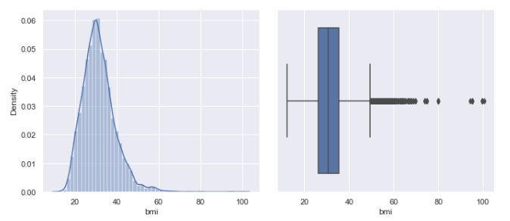

Figure 3: Distplot and Boxplot of Variable BMI

* Most of the customer’s bmi falls in the bracket of 20 – 40. There is presence of outliers, approx 2.25%. If we look at the outlier, we can see very high bmi values.
* The outlier in 'bmi' is looking incorrect entry as so much high bmi is not usually possible. So, we will treat the anomaly.

**Height:**

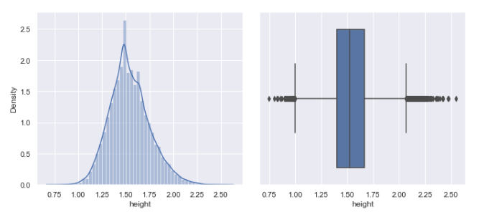

Figure 4: Distplot and Boxplot of Variable Height

* Though height is looking normally distributed but it has presence of outliers which is around 1.57%, as we imputed its values from ‘bmi’ so we will have to remove its anomaly too.
* We will treat the outliers in height column too.

**Weight:**

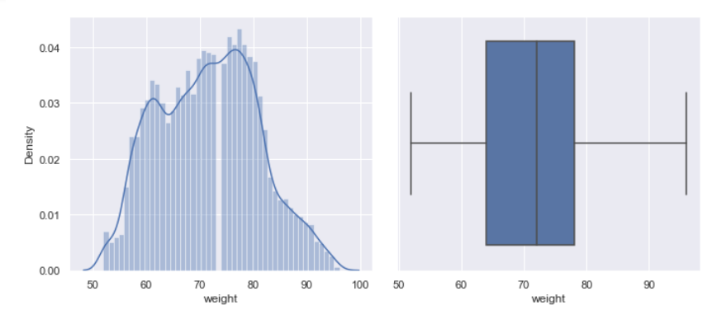

Figure 5: Distplot and Boxplot of Variable Weight

* Weight is slightly right skewed.
* Most of the people weight varies between 60 to 80 kg.
* Data shows no outliers.

**Categorical columns.**

* **Adventure_sports:**

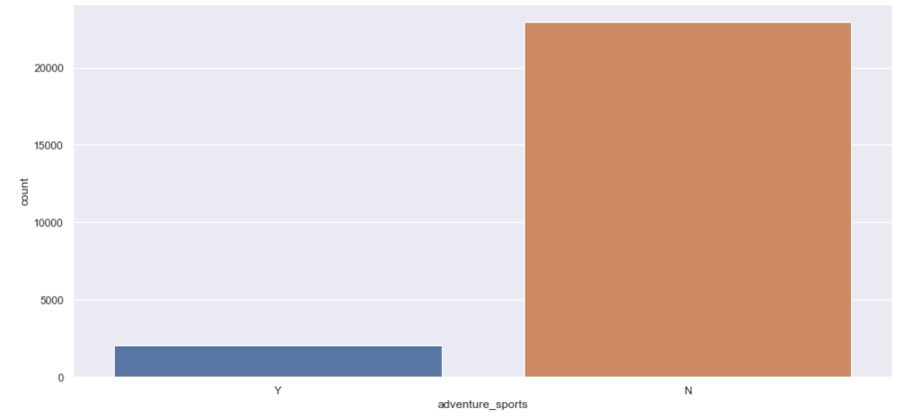

Figure 6: Countplot of variable Adventure Sports

* It is a very important variable in deciding the insurance cost of the client. But in here we can see that most of the insurance holders are not into Adventure sports.
* **Gender:**

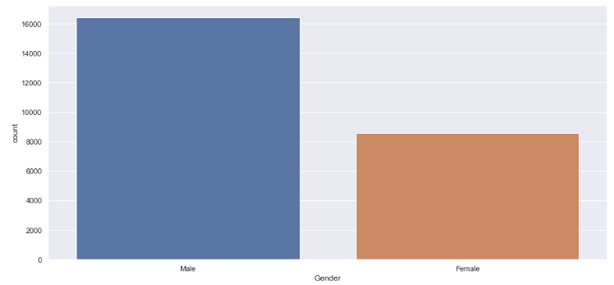

Figure 7: Countplot of Variable Gender

* Since medical conditions slightly differ between genders, it affects the likelihood of a person

footing the health insurance bill. For example, the premium can be slightly higher for women of

childbearing age than men.

* Male clients are more than female clients in our dataset.
* **Smoking status:**

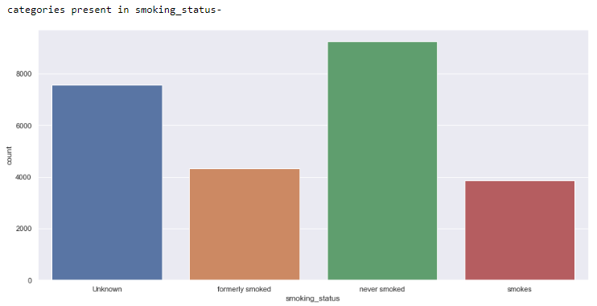

Figure 8: Countplot of variable Smoking Status

* most people don't disclose their **smoking status** when availing **health insurance**. That’s why we can see a high value count of the unknown customers.
* Company can ask for hefty premium amount to customers who are smokers but here the value

counts of these customers are less.

**Location:**

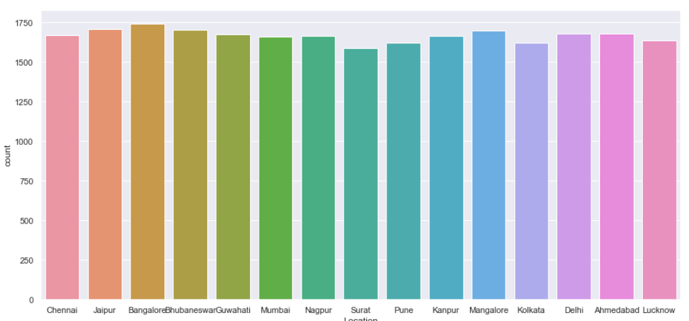

Figure 9: Countplot of variable Location

* There are 15 location in the dataset.
* The countplot doesn’t show much of variation in the count of the location recorded.
* The above plot shows that most of the customer enrolled are from Bangalore.
* **Alcohol**

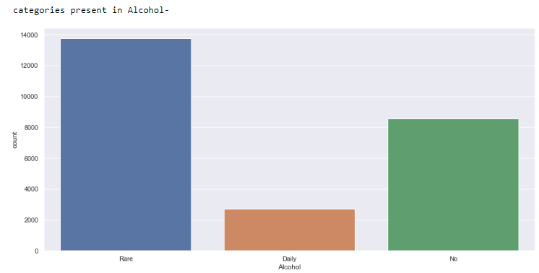

Figure 10: Countplot of Variable Alcohol

* The above plot shows higher count of people who rarely consume Alcohol.
* Count of people consuming Alcohol is less in the dataset.

**Bi-Variate/Multivariate Analysis**

We have performed Bi-variate Analysis between all the independent variable with the target variable in

our python code book. Below, we have picked few important charts to show the relation between the independent and target variable.

**Daily_avg_steps vs insurance cost**:

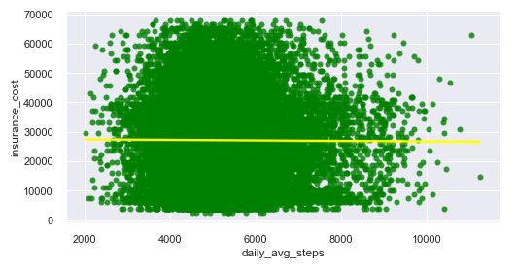

Figure 11: Regplot between daily_avg_steps vs insurance cost

* From above regression plot between daily avg steps and insurance cost shows no correlation among themselves.
* There is no linear relation between these 2 variable.
* **Bmi vs insurance cost:**

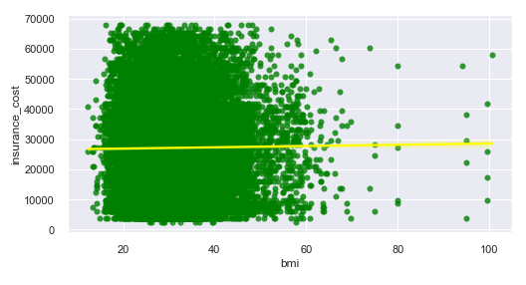

Figure 12: Regplot between BMI and insurance cost

* Bmi is a very important factor in deciding the insurance cost of the customer. Generally, high bmi means high insurance premium cost.
* But our plot shows no major realtion between the variables, i.e. insurance cost is not influenced by the bmi of the customer. It is scattered through out regardless of the bmi of the customers.
* Above plot also shows outliers in bmi.
* **Weight Vs insurance cost**:

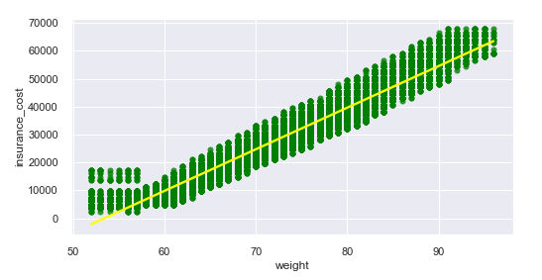

Figure 13: Regplot between weight vs insurance cost

* Customers who are overweight end up paying higher premiums for their [health insurance policies](https://www.bankbazaar.com/insurance/health-insurance.html) compared to others who are not obese or overweight.
* From the above analysis we can clearly see that the weight is highly influencing the insurance cost of the customers.
* With the increase in the weight the insurance cost is increasing and the weight of the gender is simontaniousy distributed through out.
* **Height Vs insurance cost**:

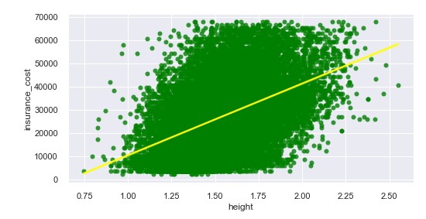

Figure 14: Regplot between Height and insurance cost with Gender

* Height is important for depicting the bmi of the customer.
* From the above analysis we can see that the height is influencing the insurance cost in the positive direction.
* We can also see presence of outliers.
* **Weight change in last 1 year Vs insurance cost**:

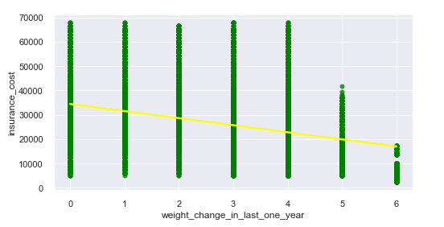

Figure 15: Regplot between weight_change_in_last_one_year Vs insurance cost

* From above our plot we can see that weight change slightly inversely associated with insurance cost.
* With the increase in weight the insurance cost has gone down.

**BMI, smoking status and insurance cost.**

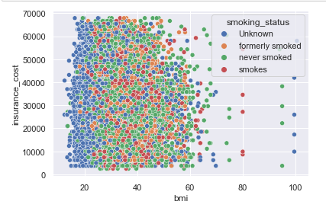

Figure 16: Scatterplot between bmi, smoking status and target variable

* Data is scattered and does not show any linear relation among themselves.

**Age, smoking status and insurance cost**

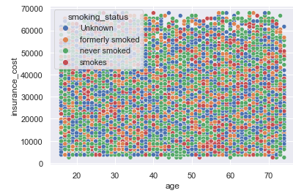

Figure 17: Scatterplot between age, smoking status and target variable.

* Above plot does not show any pattern, the date is scattered and there is no linear relation between the variables.

**Weight, smoking status and insurance cost**

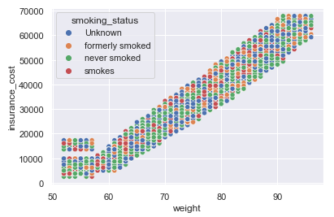

Figure 18: Scatterplot between weight, smoking status and target variable.

* Weight is showing linear relation with insurance cost.

**Location, smoking status and insurance cost**

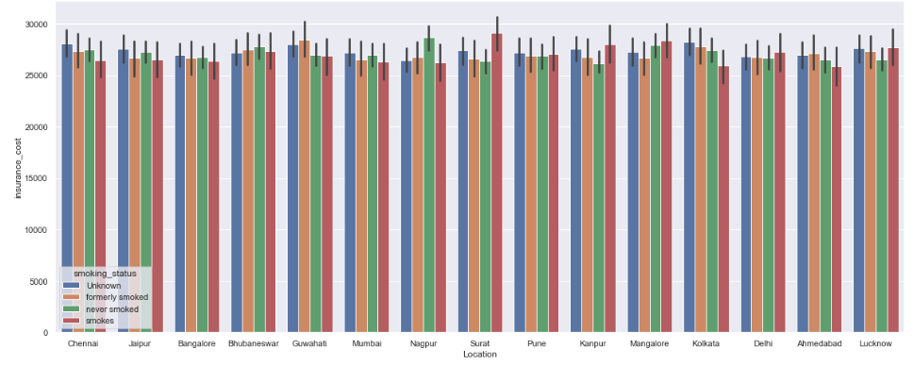

Figure 19: Barplot between Location, smoking status and target variable.

* Above plot does not show any significant variation in the data among location and insurance cost.
* All the location shows very similar sum of insurance cost.
* In surat, kanpur,mangalore smoker are paying little higher insurance cost.

**Regular check-up last year, Gender and insurance cost**

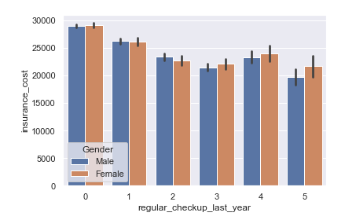

Figure 20: Barplot between regular checkup last year, Gender and target variable

* Most the applicant who has not gone for any checkup last year is showing high insurance cost then who has

done regular checkup more than 1 time.

**Weight_status, smoking status and insurance cost**

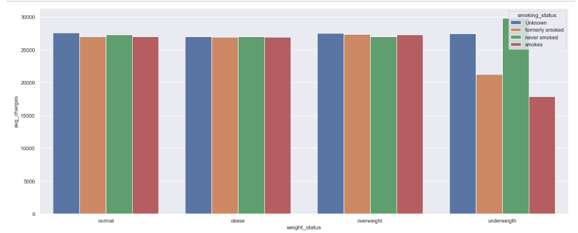

Figure 21: Barplot between weight, smoking status and target variable

* The above plot shows the distribution of avg. insurance cost in terms of weight and smoking

status.

* Applicants who are underweight and has never smoked is showing high insurance cost as compared to applicant who smokes.

**Heat map:**

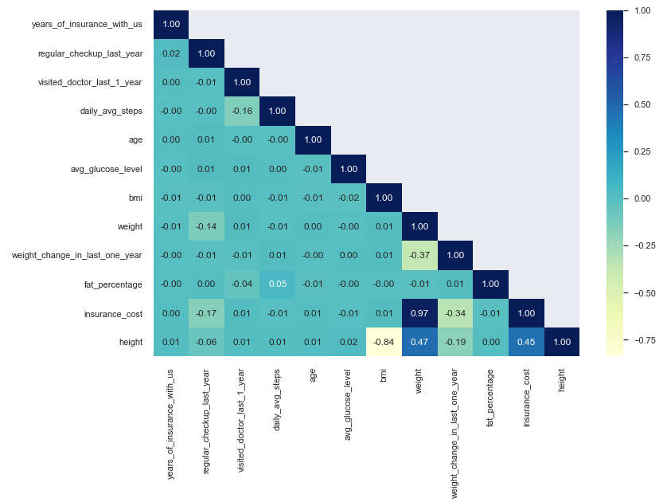

Figure 22: HeatMap

**Observation:**

1. negatively correlation between bmi and height
2. positively correlation between weight and height
3. positively correlation between weight and insurance cost
4. negative correlation between weight and weight_change_in_last_one_year
5. negative correlation between height and insurance cost
6. negative correlation between weight_change_in_last_one_year and insurance cost

**We did K-mean Clustering to find the customer segmentation.**

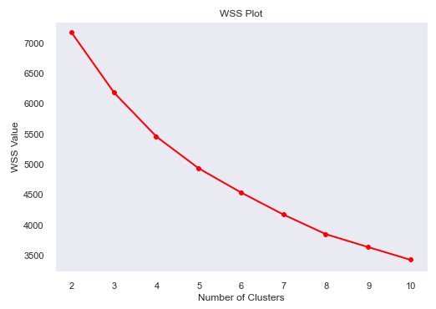

Figure 23: K-mean clustering-Elbow plot

Below is the Customer segmentation depending on the selection of k value as 3 i.e. we selected 3 clusters.

Cluster 0: Medium age people, quite a good height and high insurance cost agmong other clusters.

Cluster 1: Medium age people, medium height and low insurance cost agmong other clusters.

Cluster 2: Medium age people, medium height and high insurance cost too.

**Hypothesis based on EDA.**

* Dataset shows the maximum time the applicant has renewed their policy with the same company is 3.
* 60% of the applicant has not gone for any regular check-up with doctor in last one year.
* Only 9% of the applicant in the dataset are into adventure sports.
* Most of the applicant are student and into business.
* Count of applicant who has visited the doctor regularly in the last one year is maximum 2, 3 and 4 times.
* Count of having good and very good cholesterol is higher than high, desirable and borderline high

cholesterol level in the record.

* As per record 95% of the applicant does not have any heart disease.
* And 90% of the applicant does not show any history of major disease.
* Count of male is more as per the analysis.
* Record shows that most of the applicant are following a healthy lifestyle i.e. are never into smoking. Only 15% of the record shows smokers which is very less.
* There are 15 locations recorded in the dataset.
* There are 31% of the applicants in the record who has taken insurance cover from other company too.
* The dataset shows that applicant enrolled are rarely consuming alcohol. Only 10% of the applicant are consuming alcohol daily.
* Most of the applicant are doing moderate exercise as compared to extreme exercise.
* The proportion of weight changed in last 1 year is approx. 3 and 4 kg.
* The average daily steps done by most of applicant is approx. 5000 steps.
* The age group of the applicant is between 16 to 74 years.
* Weight of the applicant varies from min of 52 kg to 96kg and having fat percentage ranging from 11 to 42%

in the body.

* The BMI is showing range of 12 to 100 which is quite extreme.
* Customer with smoking and formerly smoking habit who does adventure sports shows high insurance cost.
* customer who has othet major disease and consume alcohol daily is showing avg insurance cost low than others.
* Whereas customer having other major disease avg insurance cost is same has customer having no other major diease in case they are rarely consuming Alcohol
* Customer who has othet major disease and formerly smoked are showing low insurance cost
* Whereas avg incurance cost for customer having major disease who smokes and never smokes are showing same.
* Average insurance cost is less for customer having heart desc history for customer who consume alcohol daily as compared to others who doesnt drink and rarely drinks
* Average insurance cost for customer having heart desc history for smokers is less as compare to other smoking categories.

# Model Development

**EDA Insight before Model Building:**

* The data has lots of categorical variables, discreet variables and numerical variables.
* This looks like a standard regression problem.
* In the data frequencies are varying so we will be doing scaling.
* From our domain knowledge we learned that Location places a very important role in the cost of the insurance but from the EDA we noticed that all the Locations have equal distribution of insurance cost
* From our domain knowledge we also learnt that people with pre-existing disease and high glucose level pays more insurance cost than that of healthier people but in our EDA, we noticed that they are not making any difference and customers without health problems, heart disease and low glucose level are also paying higher insurance cost.
* We had missing values in bmi and it is an important variable in predicting the insurance cost, so to get the values right we needed weight and height. So, we introduced a new variable ‘height’ into the dataset.
* A higher BMI means that the individual is at a higher risk of heart diseases and might frequently visit the hospitals due to weight-related issues.
* From our EDA we found out that height is showing a negative linear relationship with the insurance cost. Because height is used in imputing the bmi and as mentioned above bmi is very important in insurance cost.
* Weight changed in last one year is showing negative correlation with insurance cost. It means customers whose weight is fluctuating a lot they are paying less premium amount. The reason could be, that the customer is trying healthy lifestyle and their weight is reducing towards better. Life insurance rates are typically higher if you're overweight or obese, since it is taken into account the weight and height when setting premiums.
* Overall if we look at the EDA, we can see that ‘weight’ is a very important variable which is affecting insurance cost. Overweight or people suffering from obesity pay high premium as part of their health insurance policy is that obesity is known to be the cause of many other diseases such as diabetes, hypertension, etc.

Before doing **model building**, we will convert our object variables into numerical variables using one hot encoding. Converting the other 'object' type variables as dummy variables.  Dummy coding uses only ones and zeros to convey all of the necessary information on group membership, we will drop the zeros here, by using drop first command.

Also, we performed Scaling using StandardScaler() on only numerical variables(refer to python code book).

**Extract the target column into separate vectors for training set and test set:**

Before splitting we need to separate the target variable. Here the Target variable is ‘insurance_cost’.

Now let’s extract the target column ‘insurance_cost’ and make two variables X and y. X will contain all the independent variable and y will be our target column. We must do this before splitting the data into train and test sets. We will split the data into train set and test set at a ratio of 80:20.

List of Algorithms Selected for Model Building:  
1)     Linear Regression  
2)     Decision Tree Regression  
3)     Random Forest Regression  
4)     AdaBoost Regression  
5)     Gradient Boosting Regression  
6)     XGB Regression  
7)     Lasso Regression  
8)     Ridge Regression  
9)     MLP Regression And  
10) Bagging

As we see in our python code book, we have trained all the model one by one and evaluated their performance on the validation/test data.

**Let’s visualize the Train and test scores and their RMSE scores for Baseline Model (with default parameters)**

|  |  |  |  |  |
| --- | --- | --- | --- | --- |
|  | **Train Error** | **Test Error** | **RMSE Train Error** | **RMSE Test Error** |
| **Linear Regression** | 0.949761 | 0.949936 | 2.24E-01 | 0.222788 |
| **Decision Tree** | 1 | 0.909335 | 3.13E-17 | 0.299811 |
| **Lasso** | 0 | -0.000184 | 1.00E+00 | 0.995789 |
| **Ridge** | 0.949757 | 0.94994 | 2.24E-01 | 0.222779 |
| **Random Forest** | 0.993238 | 0.951199 | 8.23E-02 | 0.219958 |
| **AdaBoost Regressor** | 0.947336 | 0.947702 | 2.30E-01 | 0.227704 |
| **Gradient Boosting** | 0.955841 | 0.954789 | 2.10E-01 | 0.211715 |
| **XGB Regressor** | 0.973696 | 0.952063 | 1.62E-01 | 0.218004 |
| **MLP Regressor** | 0.968709 | 0.938206 | 1.77E-01 | 0.247513 |
| **Bagging** | 0.990688 | 0.946764 | 9.66E-02 | 0.229736 |

Table 4: Model Evaluation Table of All Baseline Models

**Observation:**

* We tried 10 algorithms with default parameters.
* The least RMSE score is found in Gradient Boosting, which is 2117.15, with 95% score.
* The second-best model is XGB regressor with the test score of 95.2% and RMSE score of 2180.04.
* The third-best model is Random Forest regressor with test score of 95% and RMSE score of 2199.58.

Adding further to our analysis, we tried testing few iterations on our selected models doing **hyperparameter tuning.**

**Hyperparameter Tuning**

For finding the optimal hyperparameters which will help us achieve the best performing model, we have decided to use GridSearchCV and RandomSearch.

Keeping few important Hyperparameters in mind we tried evaluating our models. Below is the evaluation for Final model selection.

**Gradient Boosting Hyperparameter Tuning Model Evaluation:**

We have chosen n_estimators, max_depth, min_sample_split, min_samples_leaf, learning_rate as parameters and build few iterations changing the values of the same to find the best accuracy and rmse score of the model. Below is the evaluation table to compare the same.

|  |  |  |  |  |
| --- | --- | --- | --- | --- |
|  | **Train Error** | **Test Error** | **RMSE Train Error** | **RMSE Test Error** |
| **GB:I1** | 0.95008 | 0.94446 | 0.223669 | 0.234653 |
| **GB:I2** | 0.949 | 0.94118 | 0.226062 | 0.241477 |
| **GB:I3** | 0.94028 | 0.93529 | 0.244627 | 0.253285 |
| **GB:I4** | 0.95588 | 0.95488 | 0.210281 | 0.211495 |
| **GB:I5** | 0.95592 | 0.95471 | 0.210181 | 0.211908 |

Table 5: Model Evaluation Table of Gradient Boosting Regressor-Hyperparameter Tuning

**Observation**: We observe that with every iteration the accuracy and RMSE values are improving.

We can also say that while predicting the insurance cost in future of applicants, the predicted insurance cost will be +- 2119.08

**Note:** Model is showing that Weight is most importance feature of the dataset. Also, insurance covered by any other company is showing slight importance too.

**Random Forest Hyperparameter Tuning Model Evaluation**:

We used most important parameters like max_depth, max_features, min_samples_split and min_samples_leaf and evaluated the model. Below is the evaluation done based on these parameters.

|  |  |  |  |  |
| --- | --- | --- | --- | --- |
|  | **Train Error** | **Test Error** | **RMSE Train Error** | **RMSE Test Error** |
| **RF:I1** | 0.956481 | 0.953254 | 0.208833 | 0.215278 |
| **RF:I2** | 0.956428 | 0.953289 | 0.208959 | 0.215197 |

Table 6: Model Evaluation Table of RandomForest Regressor-Hyperparameter Tuning

**Observation**: Very Slight improvement in the score. On metric evaluation, still Gradient Boosting Regressor is performing slightly better than RF.

We can also say that while predicting the insurance cost in future of applicants, the predicted insurance cost will be +- 2151.97

Note: Model is showing that Weight is the most important feature that is influencing the target variable. Also, daily_avg_steps, avg_glucose_level, age, fat_percentage, height, bmi and insurance covered by any other company too is showing importance while evaluating the dataset with Random Forest Model.

**XGB Regressor Hyperparameter Tuning Model Evaluation**:

We have chosen 5 of the hyperparameters that are usually having a high impact on performance; “**max_depth**”, “**min_child_weight**”, “**subsample**”, “**cosample_bytree**”, and “**alpha**”. The evaluation metric used to train the model is the root mean squared error (**RMSE**).

|  |  |  |  |  |
| --- | --- | --- | --- | --- |
|  | **Train Error** | **Test Error** | **RMSE Train Error** | **RMSE Test Error** |
| **XGB:I1** | 0.955805 | 0.954798 | 0.210448 | 0.211693 |
| **XGB:I2** | 0.955805 | 0.954798 | 0.210448 | 0.211693 |

Table 7: Model Evaluation Table of XGB Regressor-Hyperparameter Tuning

Observation: Metric score of XGB is very close to Gradient Boosting model. With 95.47% of accuracy and 2116.93 error score of RMSE, we observe that XGB is equally performing well on the dataset.

We can also say that while predicting the insurance cost in future of applicants, the predicted insurance cost will be +- 2116.93

**FINAL MODEL SELECTED: Gradient Boosting Regressor & XGB Regressor**

The performance of the model on the training set is 95.5% whereas on test set it is 95.47%. so we are able to explain the variance in insurance cost up to an extent of 95.4% with the help of the independent variable. Gradient Boosting and XGB both are giving us an error of approx. 2117.15 monetary unit which is the least among all the models.

# Final Recommendation

**Business Recommendation**:

As we are aware that the insurance company can only make profits if it collects more money from customer rather than spending. Below are the few areas which we felt are important areas to look into from our current dataset which will help the company to make profits.

* **Gender**: Company should have a difference in insurance cost for men and women, the 3 reasons for this as the experts say are - Women are more likely to visit doctors, take prescriptions, and be subject to chronic diseases.
* We would like to recommend looking into the data of **heart disease** and **other major disease** **history** of the customers as the current data shows no relevant output. We feel these are very important factors which may help the company to decide on the insurance cost of the customers. The data need to be revalidated again for these factors to capture the relevant information about the customers as we feel that it is not possible that customers in the data shows no history of disease.

Past medical records are crucial in deciding the cost. If the applicant has a history of suffering from illnesses or have a pre-existing disease, then their premium will be higher.

* **Location** plays an important role in deciding the insurance cost as in metro cities the premium is usually higher compared to the small towns. If we look at the insurance cost against the Location the record doesn’t show a difference in charges according to location, which is a major area to look at.
* Only 15% of the applicant are **smokers** in this dataset. But insurance cost of these applicants is not higher as compared to other subcategories in the data. We recommend the company to look into the policy charges of these applicant and revalidate the charges.
* This dataset shows only 10% of the applicant are consuming **alcohol** which is a very small segment of the applicants. As per data insurance cost are not higher as compared to rare and applicant not consuming alcohol. Company should review the insurance cost of these applicants.
* **Age**-One of the critical factors which affect the insurance cost. Our current dataset shows no evidence of high or low insurance cost against the age of the applicant. Generally, the insurance company should follow one thumb rule- higher the age, higher the cost. Older people are more at a higher risk of suffering from illness than youngsters.
* **Occupation**-Applicant nature of work and the amount of risk that they are exposed to at work, affects the premium charges. Someone who is a student, their premium will be less, but if someone works in an environment like a construction site or a factory where the risk of being injured is high, then the premium amount will be higher.

Company should focus more on applicant who are salaried and business personal. Long hour of work, unhealthy lifestyle, stress leads to health risk.

* **BMI-**which is another factor which affects the insurance cost shows no relevant information in our dataset. i.e. applicant with high BMI should pay high insurance cost. People with high BMI are at risk of serious ailments including heart diseases, type 2 diabetes, breathing problems, high blood pressure and cancer. Company should review their record as the dataset doesn’t show high insurance cost for applicant who are having high BMI’s.
* Our dataset does not have record of applicant **dependents** like how many children they have. Insurance cost can be more for a plan that also covers a spouse and/or dependents. So, a company can introduce a new column which gives information about family.
* Another factor which we felt company can take into consideration is the applicant who are **enrolling new**. **Years of insurance with the company** can play a vital role too, new applicants would make frequent trips to doctors and hospitals to start reaping benefits of the health insurance policy. Therefore, they increase the premium rates to cover all expenses. Hence, company can charge more insurance cost to these kinds of applicants.

**Based on various model building and analysis, we would like to recommend ‘Gradient Boosting Regressor’ & ‘XGB Regressor’ algorithm of ensemble method of Machine Learning Techniques.**

* Using GBR or XGB, for Training the data and using it for predicting the insurance cost will be hassle free, faster and higher efficiency.
* Often provides predictive accuracy that cannot be trumped.
* GBR and XGB has lots of Flexibility-can optimize on different loss functions and provides several hyper parameter tuning options that make the function fit very flexible.
* GBR and XGB requires minimal data pre-processing, which helps us in implementing this model faster with lesser complexity.
* Missing data is one of the issues while training a model. GBR and XGB handles the missing data on its own and does not require us to handle it explicitly.
* XGB is also known as Extreme Gradient Boosting.

**Hence, XGB or Gradient Boosting Regressor is the best Model for predicting the insurance cost.**



1)<https://www.analyticsvidhya.com/blog/2016/03/complete-guide-parameter-tuning-xgboost-with-codes-python/>

2)<https://www.analyticsvidhya.com/blog/2016/02/complete-guide-parameter-tuning-gradient-boosting-gbm-python/>

***Appendix***



